|  |
| --- |
|  |
|  |

|  |  |  |  |  |  |
| --- | --- | --- | --- | --- | --- |
| REVISION HISTORY | | | | | |
| Ver. | Description of Change | Author | Date | Approved | |
| Name | Effective Date |
| 1.0 | Initial status | [Kiryl Bucha](mailto:Kiryl_Bucha@epam.com) | 12-JAN-2012 |  |  |
| 2.0 | Updated in accordance with renewed content | [Elias Nema](mailto:Elias_Nema@epam.com) | 20-JAN-2014 |  |  |

Contents

1. Data 3

2. Advanced Grouping tasks – Reports 3

2.1. Create Test AdHoc SQL - Daily Report (CUBE) 3

2.2. Create Test AdHoc SQL – ROLLUP by Time 3

# Data

The Main Task is to generate test data on Storage layers objects that was created on task 01.

Task Results:

* Scripts put on Git
* Storage Layers Objects test data select screenshots

Fact table generation:

INSERT

INTO cls_orders

(

order_id,

order_dt,

seller_id,

customer_id,

payment_method_id,

delivery_method_id,

product_info_id,

sum_of_payment,

insert_dt

)

SELECT order_id,

order_dt,

seller_id,

customer_id,

payment_method_id,

delivery_method_id,

product_info_id,

sum_of_payment,

SYSDATE AS insert_dt

FROM

(SELECT TRUNC(dbms_random.value(100000000000, 9999999999999)) AS order_id ,

TRUNC ( (sysdate +4) - dbms_random.value ( 1, 1000 ) ) AS order_dt,

ROUND ( dbms_random.value (

(SELECT MIN ( seller_id)

FROM bl_3nf.ce_sellers

WHERE UPPER(SUBSTR(TRIM(is_active),1,4))='TRUE'

),

(SELECT MAX ( seller_id)

FROM bl_3nf.ce_sellers

WHERE UPPER(SUBSTR(TRIM(is_active),1,4))='TRUE'

))) AS seller_id,

ROUND ( dbms_random.value (

(SELECT MIN ( customer_id )

FROM bl_3nf.ce_customers

WHERE UPPER(SUBSTR(TRIM(is_active),1,4))='TRUE'

),

(SELECT MAX ( customer_id )

FROM bl_3nf.ce_customers

WHERE UPPER(SUBSTR(TRIM(is_active),1,4))='TRUE'

) ) ) AS customer_id,

ROUND ( dbms_random.value (

(SELECT MIN ( payment_method_id )

FROM bl_3nf.ce_payment_methods

WHERE UPPER(SUBSTR(TRIM(is_active),1,4))='TRUE'

),

(SELECT MAX ( payment_method_id )

FROM bl_3nf.ce_payment_methods

WHERE UPPER(SUBSTR(TRIM(is_active),1,4))='TRUE'

) ) ) AS payment_method_id,

ROUND ( dbms_random.value (

(SELECT MIN ( delivery_method_id )

FROM bl_3nf.ce_delivery_methods

WHERE UPPER(SUBSTR(TRIM(is_active),1,4))='TRUE'

),

(SELECT MAX ( delivery_method_id )

FROM bl_3nf.ce_delivery_methods

WHERE UPPER(SUBSTR(TRIM(is_active),1,4))='TRUE'

) ) ) AS delivery_method_id,

ROUND ( dbms_random.value (

(SELECT MIN ( product_info_id )

FROM bl_3nf.ce_product_info a

INNER JOIN bl_3nf.ce_products b

ON a.product_srcid = b.product_srcid

WHERE UPPER(SUBSTR(TRIM(is_active),1,4))='TRUE'

),

(SELECT MAX ( product_info_id )

FROM bl_3nf.ce_product_info a

INNER JOIN bl_3nf.ce_products b

ON a.product_srcid = b.product_srcid

WHERE UPPER(SUBSTR(TRIM(is_active),1,4))='TRUE'

) ) ) AS product_info_id,

ROUND ( dbms_random.value( 100, 99999), 2) AS sum_of_payment

FROM

(SELECT * FROM dual CONNECT BY level <1000000

)

);

Fact table contains 999 999 rows:



Fact_table:

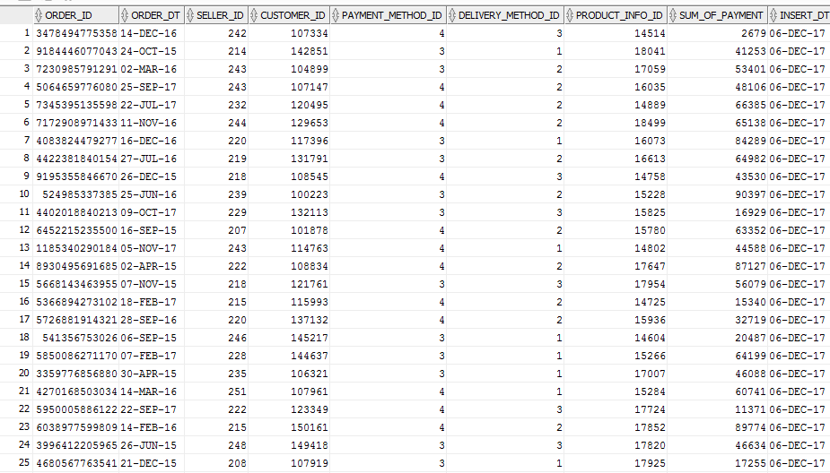

Star Scheme: 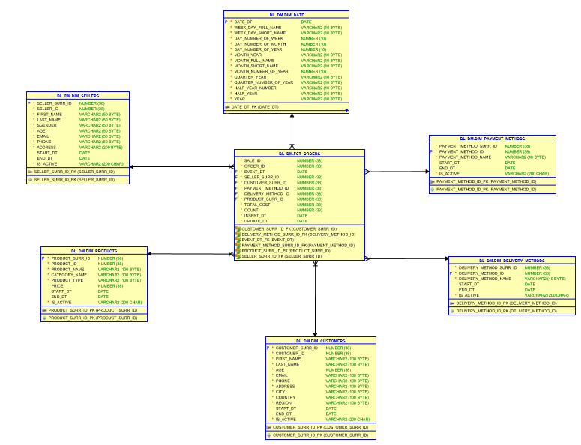

# Advanced Grouping tasks – Reports

## Create Test AdHoc SQL - Daily Report (CUBE)

Requirements:

* Use CUBE Extension, ROLLUP, Grouping(), Grouping_ID functions

CUBE:

SELECT concat(p.first_name,' '

||p.last_name) AS seller,

extract(YEAR FROM fct.order_dt) AS YEAR ,

TO_CHAR(SUM(fct.sum_of_payment),'9,999,999,999') AS Sales

FROM bl_3nf.ce_sellers p,

cls_orders fct

WHERE p.seller_id = fct.seller_id

GROUP BY CUBE(concat(p.first_name,' '

||p.last_name), extract(YEAR FROM fct.order_dt))

ORDER BY concat(p.first_name,' '

||p.last_name) NULLS LAST;

This analysis provides us with opportunity to analyze sales per sellers.

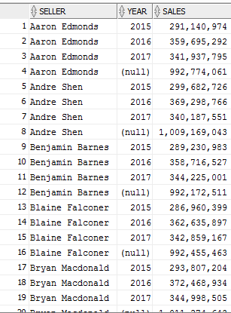

Task Results:

* Create document that will compare script results and report layouts
* Put scripts on Git

## Create Test AdHoc SQL – ROLLUP by Time

SELECT

CASE

WHEN GROUPING_id(d.year,d.quarter_of_year,d.month_of_year,order_dt)=1

THEN 'Total by month number '

||d.month_of_year

ELSE TO_CHAR(order_dt)

END AS order_dt,

CASE

WHEN GROUPING_id(d.year,d.quarter_of_year,d.month_of_year,order_dt)=3

THEN 'Total by quarter number '

||d.quarter_of_year

ELSE TO_CHAR(month_of_year)

END AS month_of_year,

CASE

WHEN GROUPING_id(d.year,d.quarter_of_year,d.month_of_year,order_dt)=7

THEN 'Total by year '

||d.year

ELSE TO_CHAR(quarter_of_year)

END AS quarter_of_year,

CASE

WHEN GROUPING_id(d.year,d.quarter_of_year,d.month_of_year,order_dt)=15

THEN 'GRAND TOTAL '

||d.year

ELSE TO_CHAR(YEAR)

END AS YEAR,

SUM(sum_of_payment),

grouping_id(d.year,d.quarter_of_year,d.month_of_year,order_dt) AS gr

FROM cls_orders f

LEFT JOIN bl_dm.dim_date d

ON f.order_dt=to_date(d.date_id)

GROUP BY rollup(d.year,d.quarter_of_year,d.month_of_year,order_dt)

ORDER BY gr DESC;

This analysis provides us with opportunity to analyze sales per date criteria.

